

**DEPARTMENT OF ARTIFICIAL INTELLIGENCE AND DATA SCRIENCE**

**End-of-Life Navigator**

**23ITR201 & FUNDAMENTALS OF WEB DESIGN**

**MINI PROJECT**

**REPORT**

**NAME : VIBISHAN A**

**ROLL.NO : 717823I260**

**TABLE OF CONTENTS**

|  |  |
| --- | --- |
| **ABSTRACT** | **3** |
| **1. INTRODUCTION** | **4** |
| **1.1. Objective** | **5** |
| **2. REQUIREMENTS SPECIFICATION** | **7** |
| **2.1 Requirements** | **8** |
| **3. DETAILED DESIGN** | **10** |
| **94. PROJECT IMPLEMENTATION** | **25** |
| **5.CONCLUSION** | **29** |
|  |  |

# ABSTRACT

Our DNR (Do Not Resuscitate) webpage serves as an invaluable resource for individuals, families, and healthcare professionals navigating the complex terrain of end-of-life care preferences and protocols. In a world where medical advancements offer both prolonged life and difficult decisions, understanding and documenting one's preferences regarding resuscitation is paramount.

The webpage provides a comprehensive exploration of the DNR order, elucidating its nuanced implications, legal ramifications, and ethical considerations. From clarifying what constitutes resuscitative measures to outlining the decision-making process behind a DNR order, our platform equips users with the knowledge needed to make informed choices aligned with their values and wishes.

Central to our webpage is a meticulously curated directory of medical centers and healthcare facilities specializing in end-of-life care. This directory not only connects users with institutions that honor and implement DNR orders but also elucidates their unique protocols and procedures. Through this resource, individuals can confidently navigate the healthcare landscape, secure in the knowledge that their preferences will be respected and upheld.

Furthermore, our webpage serves as a catalyst for meaningful conversations surrounding end-of-life care preferences. With resources and guidance on initiating discussions with loved ones and healthcare providers, we facilitate open dialogue and foster a culture of empathy and understanding.

Ultimately, our mission is to empower individuals to assert autonomy over their end-of-life care decisions, ensuring that their wishes are honored with dignity and compassion. By demystifying the complexities of DNR orders and providing accessible resources, our webpage serves as a beacon of clarity and support in navigating life's most delicate moments.

# INTRODUCTION

In an era where informed decision-making and patient autonomy are paramount in healthcare, the creation of a dedicated web page for Do Not Resuscitate (DNR) orders serves as a vital resource for individuals, families, and healthcare professionals alike. A DNR web page provides comprehensive information, guidance, and support regarding end-of-life care preferences, particularly in situations where resuscitative measures may not align with a person's wishes or quality of life goals.

At its core, a DNR web page serves as a beacon of clarity and empowerment, offering users a platform to explore, understand, and document their preferences regarding resuscitation in the event of cardiac or respiratory arrest. Through clear and accessible information, users are equipped with the knowledge necessary to make informed decisions that align with their values, beliefs, and personal circumstances.

Furthermore, a DNR web page facilitates communication and collaboration among stakeholders involved in end-of-life care, including patients, family members, caregivers, and healthcare providers. By providing resources for initiating discussions, navigating legal and ethical considerations, and accessing support services, the web page fosters a culture of open dialogue and shared decision-making, ensuring that individual preferences are respected and honored throughout the healthcare journey.

In this digital age, a DNR web page harnesses the power of technology to bridge gaps in knowledge, accessibility, and communication surrounding end-of-life care preferences. Whether it's accessing educational materials, creating and managing DNR orders, or connecting with relevant healthcare resources, users can engage with the web page in a user-friendly and secure manner, empowering them to assert control over their healthcare decisions with dignity and compassion.

In essence, a DNR web page embodies the principles of patient-centered care, autonomy, and respect for individual preferences, serving as a valuable tool in promoting quality end-of-life care experiences for all stakeholders involved. As society continues to evolve, so too does the importance of accessible and informative resources like the DNR web page, ensuring that every individual's journey is guided by their own values, wishes, and aspirations.

## OBJECTIVES :

The project objectives for the development of a software system aimed at enhancing understanding and decision-making surrounding Do Not Resuscitate (DNR) orders. These objectives are not only critical goals but also serve as the foundation for measuring the success and effectiveness of the project.

**Below are the expanded project objectives:**

* Providing comprehensive information and education about DNR orders.
* Enabling informed decision-making processes regarding end-of-life care preferences.
* Connecting users with relevant resources and support networks.
* Facilitating communication and advance care planning among stakeholders.
* Upholding user autonomy, respect, and dignity in end-of-life care decision-making
* Regulatory Compliance
* Integration with Electronic Health Records (EHR) Systems

**To Provide Comprehensive Information and Education :** The primary objective is to develop a software system that acts as an extensive repository of information and educational resources related to DNR orders. This includes not only explaining what DNR orders entail but also delving into the nuances of their implications, legal frameworks, ethical considerations, and the broader context of end-of-life care. By offering comprehensive information, the software aims to empower users with the knowledge necessary to navigate the complexities of DNR orders confidently.

**To Enable Informed Decision-Making Processes :** A crucial aspect of the project is to empower individuals, families, and healthcare professionals to engage in informed decision-making regarding DNR orders. This involves providing clear, accessible, and unbiased information that allows users to understand the implications of their choices fully. The software should facilitate users in exploring various scenarios, weighing their options, and ultimately making decisions that align with their values, preferences, and goals for end-of-life care.

**To Connect Users with Relevant Resources and Support:** Another key objective is to establish a platform that connects users with relevant resources and support networks. This includes developing a directory of medical centers, hospitals, and healthcare facilities that specialize in end-of-life care and are proficient in honoring DNR orders. Additionally, the software should provide access to support groups, counseling services, and legal assistance to help users navigate the decision-making process and address any concerns or questions they may have.

**To Facilitate Communication and Advance Care Planning** : Effective communication is essential in discussing and documenting end-of-life care preferences. Therefore, the software aims to facilitate open and meaningful dialogue among individuals, their families, and healthcare providers. This involves providing tools, templates, and guidance for initiating conversations about DNR orders, exploring values and goals for care, and creating advance care plans. By promoting communication and advance care planning, the software seeks to ensure that users' wishes are clearly articulated and respected throughout the healthcare journey.

**To Uphold User Autonomy, Respect, and Dignity :** Central to the project objectives is the commitment to upholding the principles of user autonomy, respect, and dignity in end-of-life care decision-making. The software should empower users to assert their preferences and rights regarding their own care, ensuring that their choices are honored with compassion and sensitivity. This involves creating a user-centric platform that prioritizes accessibility, inclusivity, and cultural sensitivity, regardless of the user's background, beliefs, or circumstances.

**User Interface Design and Accessibility :** Detail the requirements for the user interface design, including considerations for accessibility standards such as WCAG (Web Content Accessibility Guidelines). Specify how the interface should be designed to cater to users of varying abilities, ensuring a user-friendly experience for all.

**Integration with Electronic Health Records (EHR) Systems**: If applicable, specify the requirements for integrating the software system with existing Electronic Health Records (EHR) systems used by healthcare providers. Detail the interoperability standards to be followed and the data exchange mechanisms to ensure seamless integration and continuity of care.

**Regulatory Compliance:** Identify any regulatory requirements or standards applicable to the software system, such as HIPAA (Health Insurance Portability and Accountability Act) compliance for handling protected health information. Specify how the software system will adhere to these regulations and ensure compliance throughout development and deployment

# REQUIREMENTS SPECIFICATION

The DNR web page should begin with a brief introduction highlighting the purpose and scope of the department's activities.

Provide a summary of the key responsibilities and goals of the DNR, such as conservation efforts, wildlife management, and environmental protection.

Include a welcoming message to visitors, inviting them to explore the various resources and information available on the website.

Conservation Efforts: Describe the DNR's initiatives and projects aimed at preserving natural habitats, wildlife, and ecosystems.

Recreational Activities: Highlight opportunities for outdoor recreation such as hiking, camping, fishing, and boating in areas managed by the DNR.

Environmental Education: Provide resources for learning about environmental conservation, sustainability, and ways the public can get involved.

Interactive Maps: Include maps showcasing parks, wildlife reserves, and other natural areas managed by the DNR, allowing users to explore locations and plan visits.

Events Calendar: Maintain an updated calendar of events such as guided nature walks, educational workshops, and volunteer opportunities.

Feedback Form: Allow visitors to provide feedback, report environmental concerns, or request information through a user-friendly form.

## 2.1 Requirements

* Functional Requirements
* Non-Functional Requirements

**Functional Requirements:**

* User Interface (UI) Design
* Information Display
* Content Display
* Contact Information
* Integration with Healthcare Systems
* Authentication and Authorization

**Non-Functional Requirements:**

* Accessibility
* Performance
* Security
* Compatibility
* Documentation
* Maintenance and Updates

**Functional Requirements :**

* User Interface (UI) Design :
* Responsive design for various screen sizes and devices.
* Clear and accessible navigation links.
* Optimized images for fast loading.
* Information Display :
* Header with navigation links to different sections.
* Consistent styling and placement of navigation elements.
* Content Display :
* Prominent display of welcome message and login link.
* Collage-style display of images with brief descriptions.
* Contact Information :
* Footer displaying organization's contact details and logo.
* Inclusion of tagline or mission statement.
* Authentication and Authorization :
* Secure login system for user authentication.
* Ability for authorized users to manage their DNR orders.

**Non-Functional Requirements :**

* Accessibility :
* Compliance with web accessibility standards.
* Keyboard accessibility and focus states for navigation.
* Performance :
* Fast loading times with optimized resources.
* Minification and caching of scripts and stylesheets.
* Security :
* HTTPS encryption for secure data transmission.
* Protection against common security threats.
* Compatibility :
* Compatibility with major web browsers and devices.
* Consideration for older browser versions and mobile devices.
* Documentation :
* Comprehensive documentation for developers.
* Explanation of HTML structure, CSS styles, and JavaScript functionality.
* Maintenance and Updates :
* Easy maintenance with clean and modular code.
* Regular updates to ensure compatibility and security.

# DETAILED DESIGN

This HTML code defines a webpage for an "End-of-Life Navigator" platform, which serves as a resource for making informed decisions about end-of-life care, particularly regarding Do Not Resuscitate (DNR) orders.

Here's a brief description of the code:

* The webpage includes a header section with a logo and navigation links.
* It features a central content section with a welcoming message and a collage of images.
* The main content is enclosed in a container with a semi-transparent background color, providing a focal point for the text.
* The footer section contains contact details and a logo.
* Additionally, CSS is used to create a hover effect on the central content container, adding a box shadow and changing the cursor to 'help' when hovered over.

Overall, the code creates a visually appealing and functional webpage for the "End-of-Life Navigator" platform, aiming to provide comprehensive resources and support for end-of-life care decisions.

**#home page(home.html)**

<html>

<head>

<title>DNR</title>

<link rel="stylesheet" href="https://stackpath.bootstrapcdn.com/bootstrap/4.5.2/css/bootstrap.min.css">

<link rel="stylesheet" href="https://cdnjs.cloudflare.com/ajax/libs/font-awesome/5.15.4/css/all.min.css">

<link rel="stylesheet" href="style.css">

<style>

.cnt:hover {

box-shadow: 0 0 10px rgb(0, 0, 0);

cursor:none;

}

</style>

</head>

<body>

<header>

<div class="container">

<div class="row justify-content-between align-items-center">

<div class="col-auto">

<img src="logo.png" alt="DNR Logo" class="logo">

<br><B>End-of-Life Navigator</B>

</div>

<div class="col-auto">

<nav class="navigation">

<a href="Home.html" class="active"><i class="fas fa-home"></i> Home<span></span></a>

<a href="MedicalCenters.html"><i class="fas fa-hospital"></i> Medical Centers<span></span></a>

<a href="AboutUs.html"><i class="fas fa-solid fa-info"></i> About Us<span></span></a>

<a href="ContactUs.html"><i class="fas fa-phone-office"></i> Contact Us

<span></span></a>

<a href="Login.html"><i class="fas fa-user"></i> Login/Sign Up

<span></span></a>

</nav> </div></div></div>

</header>

<div class="container">

<div class="content">

<h1 class="text-center" style="font-size: 5pc;">Welcome <br>to<br> End-of-Life Navigator</h1><br>

<div class="text-center details">

<a href="Login.html"><i class="fas fa-user"></i> Login</a>

</div>

<div class="collage-container">

<div class="collage-column">

<img src="image1.jpg" alt="DNR Image 1" class="img-fluid">

</div>

<div class="collage-column">

<img src="image2.jpg" alt="DNR Image 2" class="img-fluid">

</div>

</div>

<div class="cnt" style="background-color:rgba(215, 235, 253, 0.7); width:auto; padding:20px; border-radius: 30px;">

<div class="text-center"><strong>

<p>Welcome to End-of-Life Navigator, your comprehensive resource for navigating important decisions and discussions surrounding end-of-life care.</p>

<p>Our mission is to empower individuals and their families to make informed choices about their healthcare preferences, particularly in situations where resuscitative measures may not align with their wishes.</p>

<p>Explore our website to learn more about DNR (Do Not Resuscitate) orders, find medical centers and resources in your area, and connect with our compassionate team for support and guidance.</p></strong>

</div></div><br>

<div class="collage-container">

<div class="collage-column">

<img src="image3.jpg" alt="DNR Image 3" class="img-fluid">

</div>

<div class="collage-column">

<img src="image4.jpg" alt="DNR Image 4" class="img-fluid">

</div></div></div></div>

<footer>

<div class="container">

<div class="row">

<div class="col-6">

<div class="footer-contact-details">

<p>Contact Us:</p>

<p><i class="fas fa-envelope"></i> : evildreams@dnr.com</p>

<p><i class="fas fa-phone"></i> : +91 9042-3975-00</p>

</div></div>

<div class="col-6 text-right">

<img src="logo.png" alt="DNR Logo" class="logo-footer">

<p style="font-family:'Franklin Gothic Medium', 'Arial Narrow', Arial, sans-serif; color:rgb(217, 228, 238) ;">Well with ur life to <br>live a joy</p>

</div></div>

<hr style="border-top: 1px solid #fff;"> </div>

</footer>

<script src="https://code.jquery.com/jquery-3.5.1.slim.min.js"></script>

<script src="https://cdn.jsdelivr.net/npm/@popperjs/core@2.10.2/dist/umd/popper.min.js"></script>

<script src="https://stackpath.bootstrapcdn.com/bootstrap/4.5.2/js/bootstrap.min.js"></script>

</body>

</html>

**#Login Page(login.html)**

<html>

<head>

<title>DNR - Login</title>

<link href="https://stackpath.bootstrapcdn.com/bootstrap/4.5.2/css/bootstrap.min.css" rel="stylesheet">

<link rel="stylesheet" href="https://cdnjs.cloudflare.com/ajax/libs/

animate.css/4.1.1/animate.min.css">

<link rel="stylesheet" href="https://cdnjs.cloudflare.com/ajax/libs/font-awesome/5.15.4/css/all.min.css">

<link rel="stylesheet" href="style.css">

<style>

.login-form {

background-color: #fff;

border-radius: 10px;

box-shadow: 0 0 20px rgba(0, 0, 0, 0.1);

padding: 50px;

width: 500px;

margin: auto;

margin-top: 100px;

}

.form-group {

margin-bottom: 20px;

}

.form-group label {

font-weight: bold;

}

.form-group input {

width: 100%;

padding: 10px;

border: 1px solid #ccc;

border-radius: 5px;

transition: border-color 0.3s;

}

.form-group input:focus {

outline: none;

border-color: #1a0461;

}

.form-group input::placeholder {

color: #999;

}

.btn-login {

background-color: #1a0461;

color: #fff;

padding: 10px 20px;

border: none;

border-radius: 5px;

cursor: pointer;

transition: background-color 0.3s;

}

.btn-login:hover {

background-color: #041e2e;

}

.signup-link {

text-align: center;

margin-top: 20px;

color: #041e2e;

}

.signup-link a {

color: #1a0461;

text-decoration: none;

transition: color 0.3s;

}

.signup-link a:hover {

color: #041e2e;

}

</style>

</head>

<body>

<header>

<div class="container">

<div class="row justify-content-between align-items-center">

<div class="col-auto">

<img src="logo.png" alt="DNR Logo" class="logo">

<br><B>End-of-Life Navigator</B>

</div>

<div class="col-auto">

<nav class="navigation">

<a href="Home.html" ><i class="fas fa-home"></i> Home<span></span></a>

<a href="MedicalCenters.html"><i class="fas fa-hospital"></i> Medical Centers<span></span></a>

<a href="AboutUs.html"><i class="fas fa-solid fa-info"></i> About Us

<span></span></a>

<a href="ContactUs.html"><i class="fas fa-phone-office"></i> Contact Us

<span></span></a>

<a href="Login.html" class="active"><i class="fas fa-user"></i> Login/Sign Up<span></span></a>

</nav></div></div></div>

</header>

<div class="container">

<div class="content">

<div class="login-form animate__animated animate__fadeIn">

<b><h1 class="text-center"><b>Log in</b></h1></b>

<form id="loginForm" onsubmit="return validateForm()">

<div class="form-group">

<label for="email">Email or Username:</label>

<input type="text" id="email" name="email" placeholder="Enter your email or username" required></div>

<div class="form-group">

<label for="password">Password:</label>

<input type="password" id="password" name="password" placeholder="Enter your password" required> </div>

<div class="form-group">

<button type="submit" class="btn-login"><i class="fas fa-sign-in-alt"></i> Login</button>

</div></form>

<div class="signup-link">

<p>Don't have an account? <a href="SignUp.html">Sign up</a></p>

</div>

</div></div></div>

<footer>

<div class="container">

<div class="row">

<div class="col-6">

<div class="footer-contact-details">

<p>Contact Us:</p>

<p><i class="fas fa-envelope"></i> : evildreams@dnr.com</p>

<p><i class="fas fa-phone"></i> : +91 9042-3975-00</p>

</div></div>

<div class="col-6 text-right">

<img src="logo.png" alt="DNR Logo" class="logo-footer">

<p style="font-family:'Franklin Gothic Medium', 'Arial Narrow', Arial, sans-serif; color:rgb(217, 228, 238) ;">Well with ur life to <br>live a joy</p>

</div></div>

<hr style="border-top: 1px solid #fff;">

</div></footer>

<script src="https://code.jquery.com/jquery-3.5.1.slim.min.js"></script>

<script src="https://stackpath.bootstrapcdn.com/bootstrap/4.5.2/

js/bootstrap.min.js"></script>

<script>

function validateForm() {

var email = document.getElementById("email").value;

var password = document.getElementById("password").value;

var emailRegex = /^[a-zA-Z0-9._-]+@[a-zA-Z0-9.-]+\.[a-zA-Z]{2,4}$/;

var usernameRegex = /^[a-zA-Z0-9]+$/;

var passwordRegex = /^(?=.*\d.*\d)(?=.*[a-z])(?=.*[A-Z])[0-9a-zA-Z]{8,}$/;

if (email.match(emailRegex) || email.match(usernameRegex)) {

} else {

alert("Invalid email or username format");

return false;

}

if (!password.match(passwordRegex)) {

alert("Password must contain at least 8 characters, including at least two digits and one uppercase letter.");

return false;

}

if ((email === "admin@example.com" || email === "Admin") && password === "Admin123") {

alert("Login successful!");

return true;

} else {

alert("Invalid email or password!");

return false;

}

}

</script>

</body>

</html>

**#css file (style.css)**

body {

font-family: 'Times New Roman';

background-image: url('image3.jpg');

background-size: cover;

background-repeat: no-repeat;

background-attachment: fixed;

margin: 0;

padding-top: 175px;

padding-bottom: 500px;

color: #151313;

display: flex;

justify-content: center;

align-items: center;

min-height: 100vh;

position: relative;

overflow-x: hidden;

}

header {

padding: 20px;

width: 100%;

position:absolute;

top: 0;

left: 0;

z-index: 100;

background-color: rgba(255, 255, 255, 0.7);

}

.logo {

width: 100px;

height: 100px;

border-radius: 50%;

object-fit: cover;

}

.navigation {

justify-content: space-between;

}

.navigation a {

position: relative;

font-size: 1em;

color: #333;

font-weight: 600;

text-decoration: none;

padding: 10px;

transition: .5s;

}

.navigation a:hover,

.navigation a.active {

color: #333;

}

.navigation a span {

position: absolute;

top: 0;

left: 0;

width: 100%;

height: 100%;

background: #fff;

border-radius: 30px;

z-index: -1;

transform: scale(0);

opacity: 0;

transition: 0.5s;

}

.navigation a:hover span,

.navigation a.active span {

transform: scale(1);

opacity: 1;

}

.container {

margin-top: 0%;

font-size: 25px;

padding-left: 0;

padding-right: 0;

}

.content img {

margin-bottom: 20px;

border-radius: 50px;

max-width: 100%;

height: auto;

display: block;

}

.collage-container {

display: flex;

justify-content: space-between;

align-items: center;

margin-bottom:auto;

overflow-x: hidden;

}

.collage-column {

width: 45%;

border-radius: 5px;

overflow: hidden;

transition: transform 0.3s ease;

}

.collage-column img {

width: 100%;

height: auto;

object-fit: cover;

border-radius: 50px;

}

.collage-container:hover .collage-column {

transform: translateX(-5%);

}

footer {

background-color: rgba(82, 78, 78, 0.7);

color: #fff;

position: absolute;

bottom: 0;

width: 100%;

display: flex;

justify-content: flex-end;

align-items: flex-end;

}

.logo-footer {

width: 100px;

height: 50px;

border-radius: 50px;

object-fit: cover;

margin-top: 10px;

margin-bottom: 10px;

text-align: center;

}

.footer-contact-details {

padding-right: 20px;

text-align: left;

}

.details a {

background:#212121;

padding: 10px 20px;

text-decoration: none;

font-weight: bold;

color: #fff;

display: inline-block;

margin: 30px 0;

border-radius: 5px; }

# PROJECT IMPLEMENTATION

Home page :

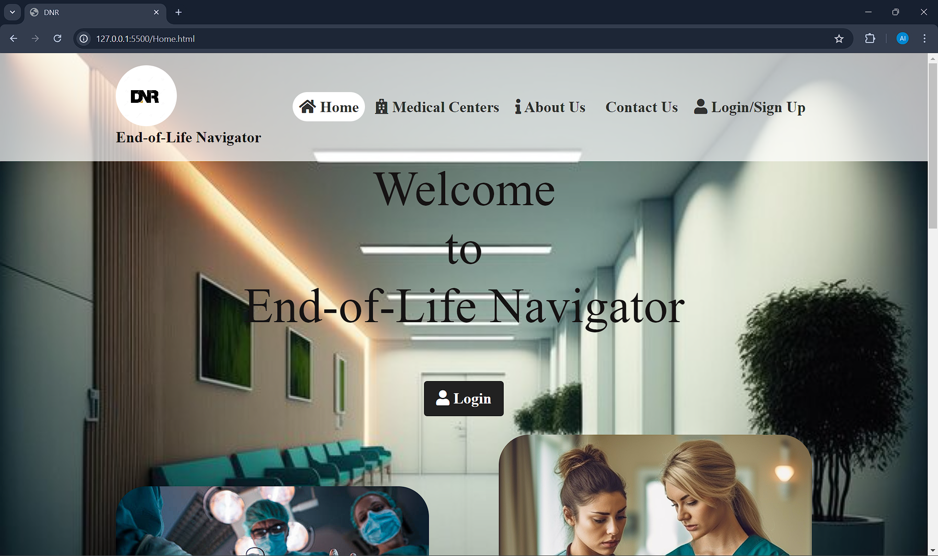

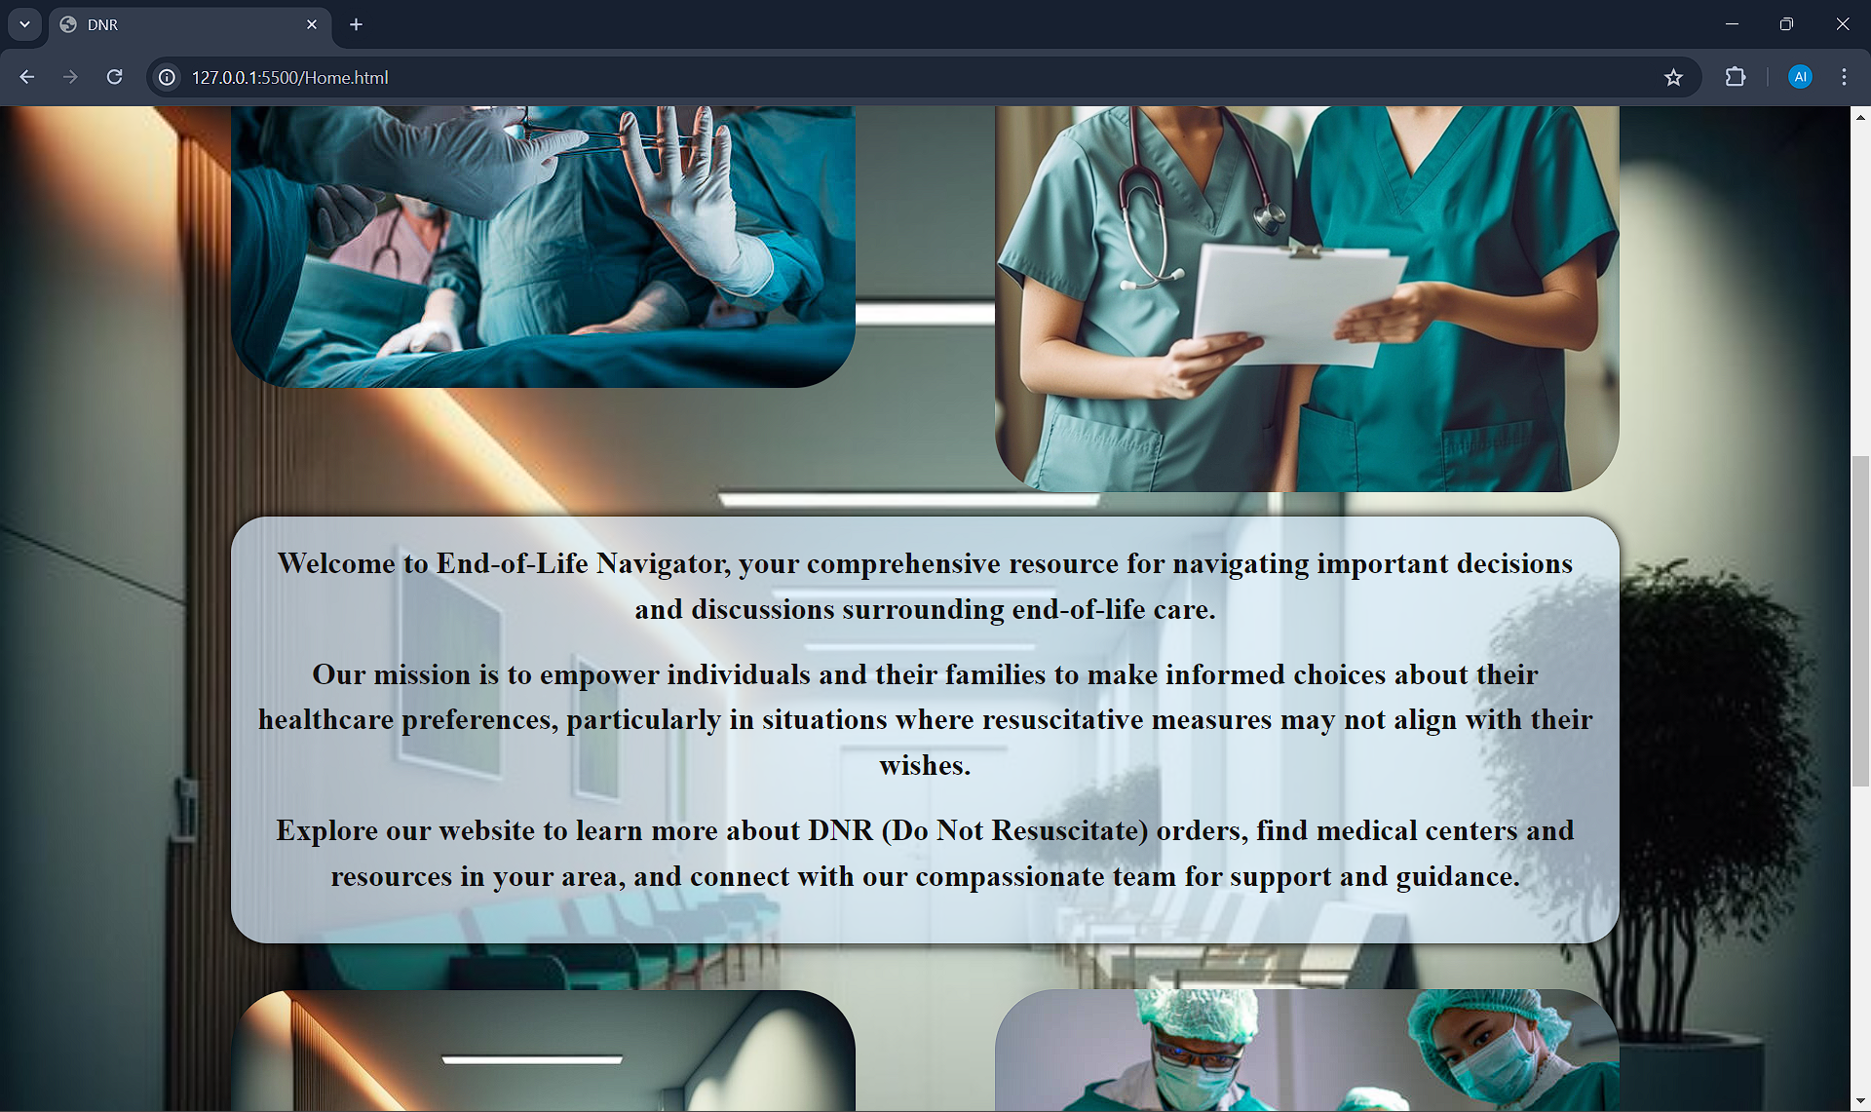

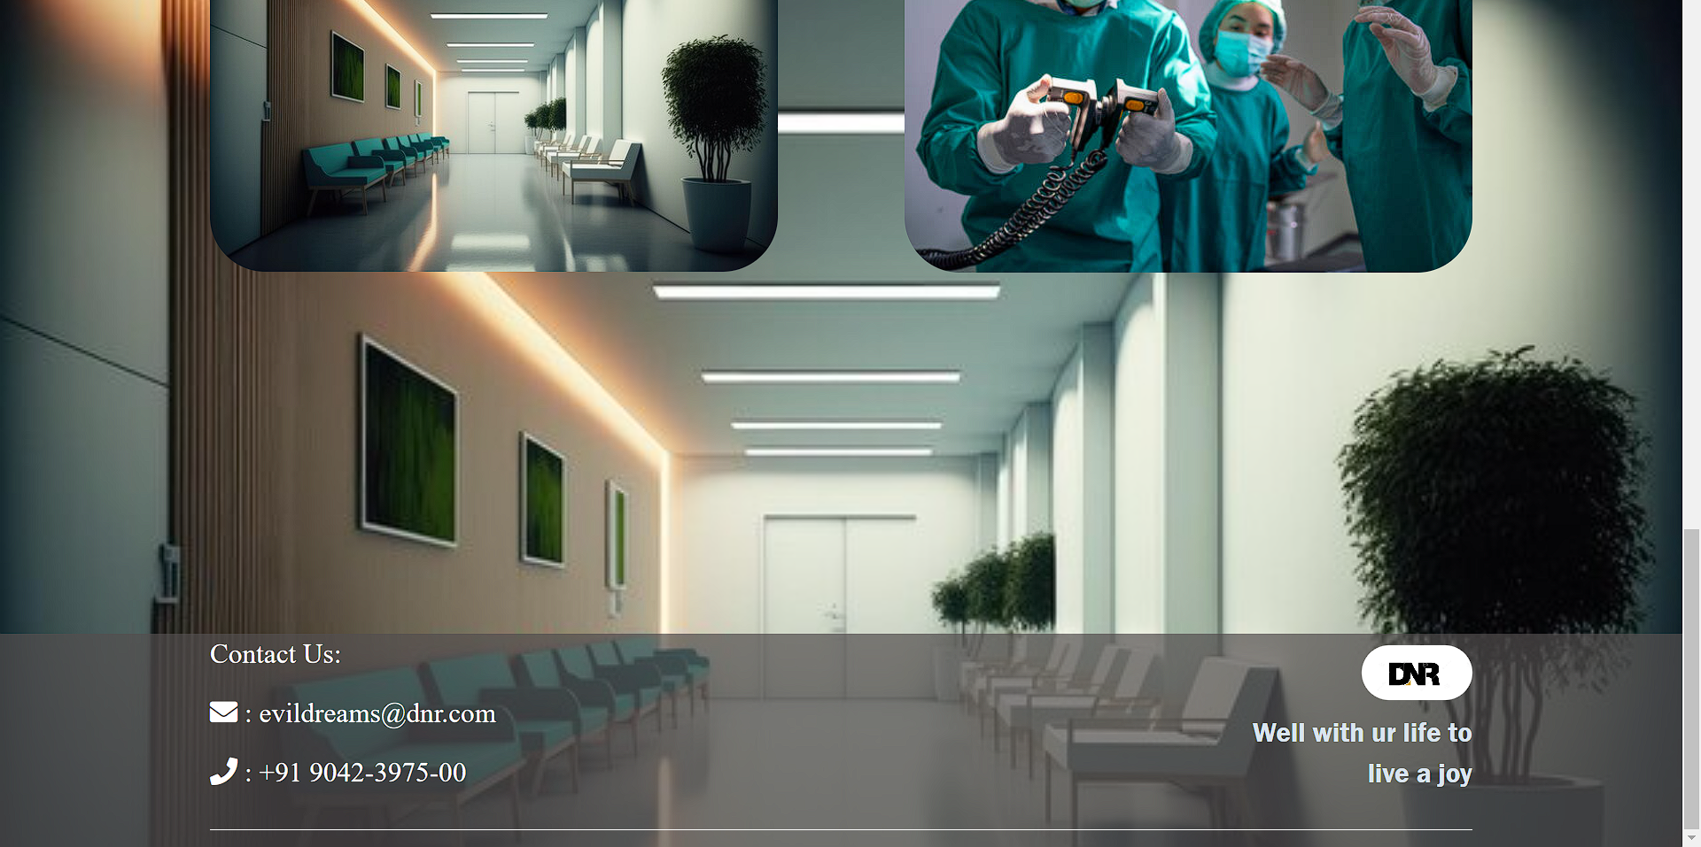

About us page :

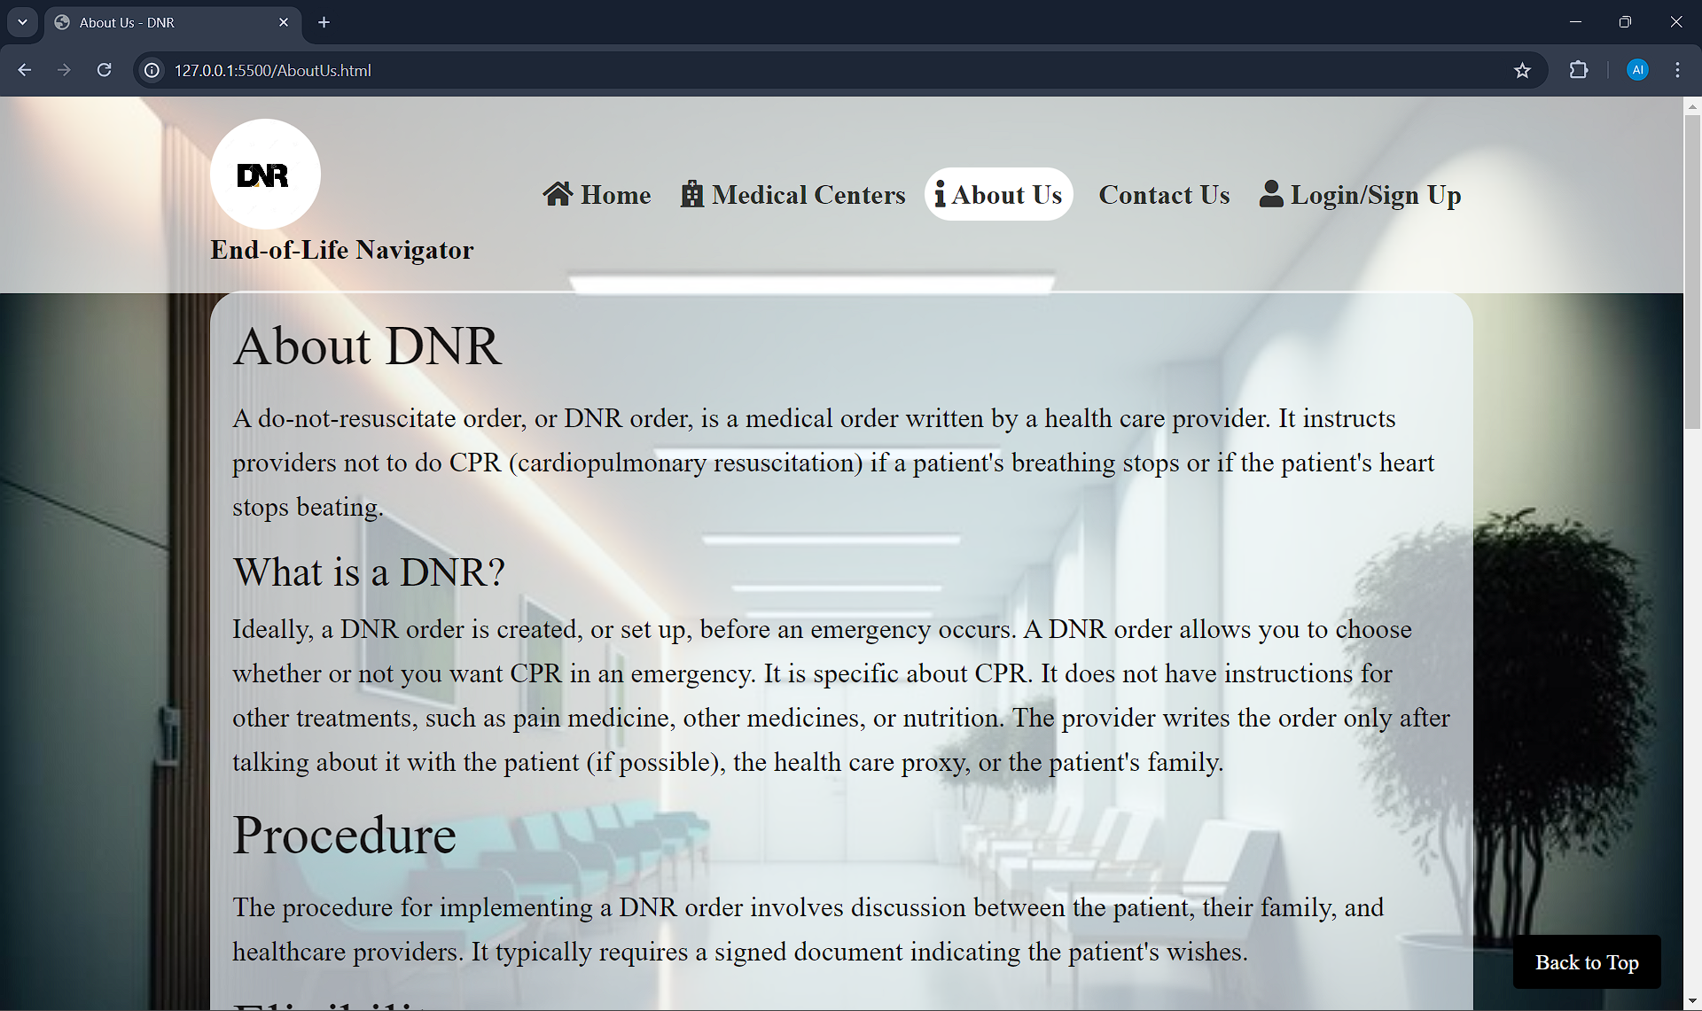

Login Page :

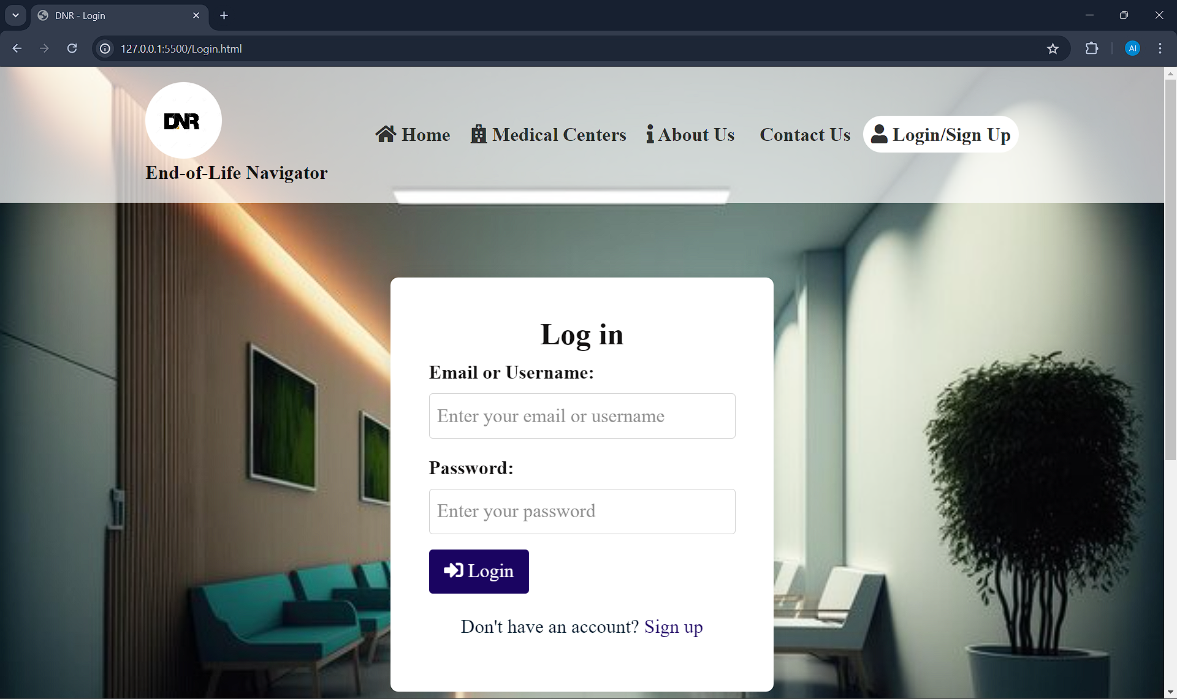

Sigup Page :

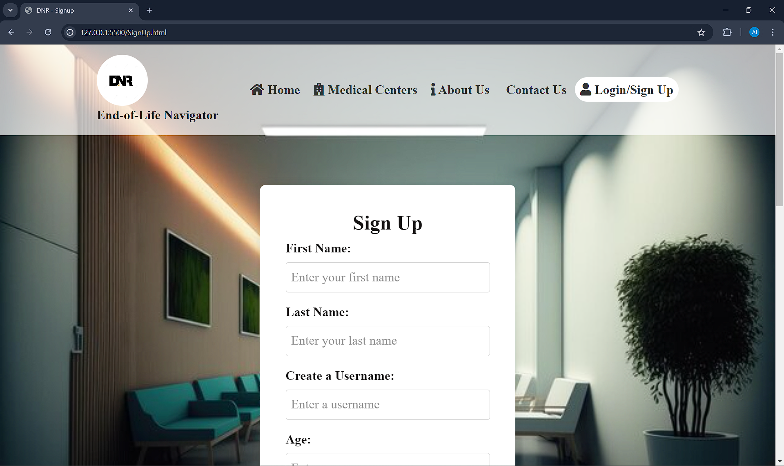

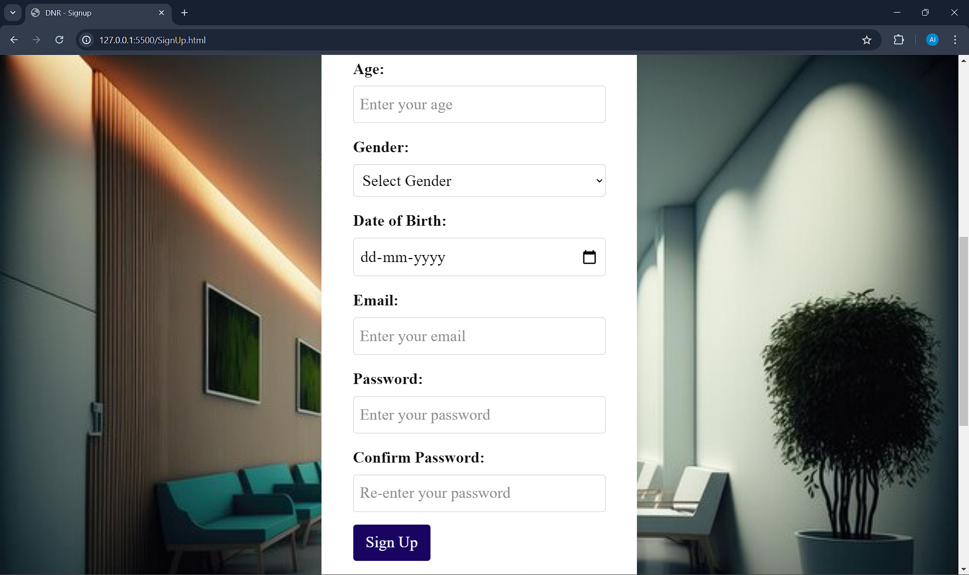

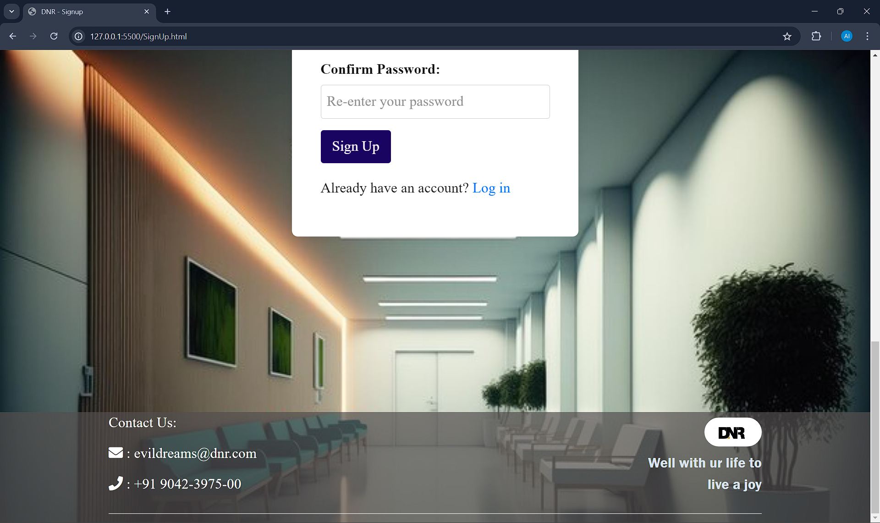

Medical Centers page :

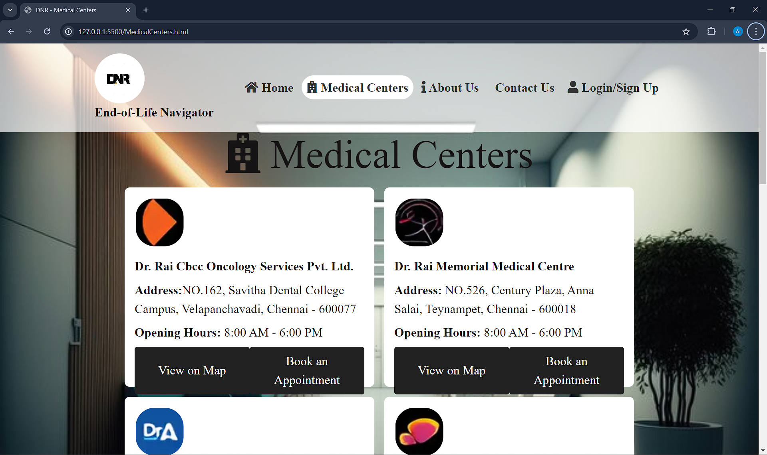

Booking a appointment progress (js):

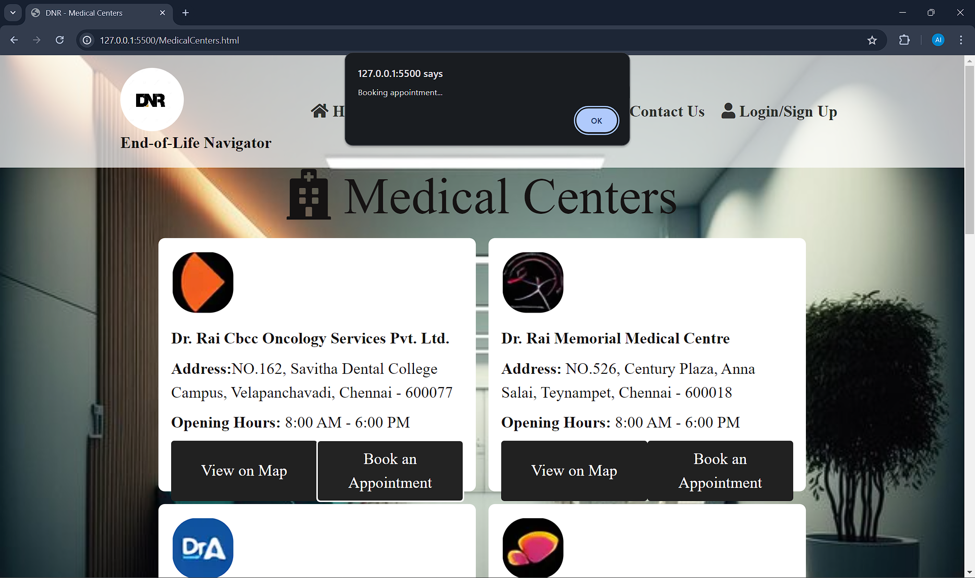

Appointment booked (js) :

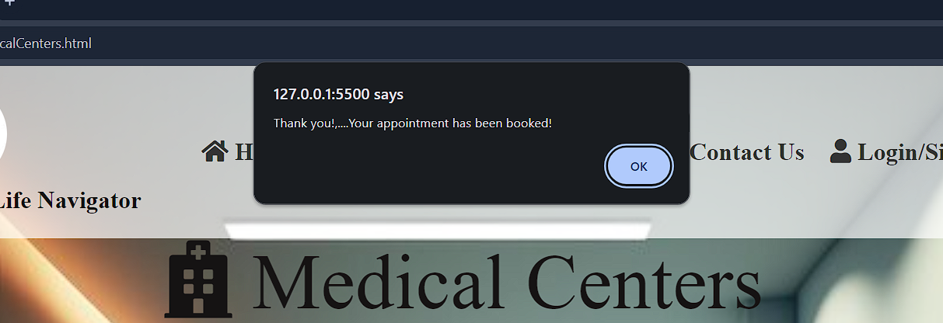

# CONCLUSION

In the journey of life, navigating the complexities of end-of-life care can be both daunting and deeply personal. The "End-of-Life Navigator" stands as a beacon of compassion, empowerment, and guidance in these moments of profound significance. Through its comprehensive resources, supportive community, and commitment to honoring individual preferences, the End-of-Life Navigator ensures that every person's final chapters are written with dignity, respect, and informed choice.

As we bid farewell to this chapter, let us carry forward the lessons learned and the connections made. May the End-of-Life Navigator continue to serve as a trusted ally, a source of comfort, and a beacon of hope for all who seek clarity, understanding, and compassion on their end-of-life journey.

Together, we embark on this path with reverence for the past, gratitude for the present, and hope for the future, knowing that the End-of-Life Navigator will remain steadfast in its mission to accompany and support us every step of the way.